Question 1 (25 pts):
Suppose there are eight students with IDs 236500360, 250987540, 262490004, 274052200, 283450902, 305342111, 317800977, and 328966568. Suppose hash table, HT, is of the size 13, indexed 0,1,2, . . ., 12. Show how these students’ IDs, in the order given, are inserted in HT using the hashing function h(k) = k % 13, where k is a student ID.

IDs | HT index
236500360 | 5
250987540 | 11
262490004 | 10
274052200 | 6
283450902 | 7
305342111 | 9
317800977 | 0
328966568 | 8

Question 2 (25 pts):
Suppose there are eight students with IDs 316500361, 330987540, 342490004, 344052199, 363450900, 385342111, 397800977, and 408966574. Suppose hash table, HT, is of the size 19, indexed 0, 1, 2, . . ., 18. Show how these students’ IDs, in the order given, are inserted in HT using the hashing function h(k)= k % 19. Use linear probing to resolve collision.

IDs | HT index
316500361 | 14
330987540 | 16
342490004 | 13
344052199 | 9
363450900 | 15
385342111 | 17
397800977 | 10
408966574 | 11

Question 3 (25 pts):
Suppose there are eight students with IDs 313577331, 330987544, 349722100, 354885711, 363450906, 375342113, 387800977, and 408966574. Suppose hash table, HT, is of the size 19, indexed 0, 1, 2, . . ., 18. Show how these students’ IDs, in the order given, are inserted in HT using the hashing function h(k)= k % 19. Use quadratic probing to resolve collision.

IDs | HT index
313577331 | 1
330987544 | 2
349722100 | 6
354885711 | 7
363450906 | 5
375342113 | 10
387800977 | 14
408966574 | 11

Question 4:
By using the hashT class provided (hashT.h ), which uses quadratic probing to resolve collision, create a hash table to keep track of student IDs and names.
(You can set your own hash table size)
Write a C++ code to;
- Ask the user to enter IDs and names of five students to be added to the hash table.
- Calculate the hash index from the student ID using the folding method.
- Add the information to the hash table.
- Ask the user to enter the student information to be deleted from the hash table.
- Remove the information from the hash table.
- Print the information.
Submit all the .cpp and .h files, and copy and paste the screenshot of the output here.

Sample output:
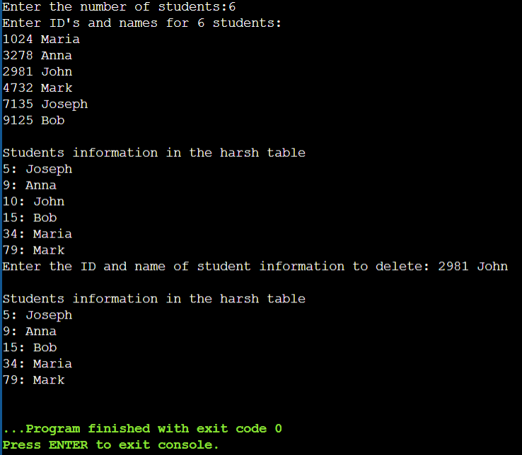

My Output:
